Module 2 [Constructor, const & static]
(for Week 2, Based on CO1)

- Problem Statement: Use the following class Test with the data members and methods
class Test{ private:
Data Member x; Data Member y; Data Member z; public:
//write methods

};

Code:

#include<iostream>
using namespace std;
class Test
{
private:
int x;
int y;
static int z;

public:
Test()
{
x=0;
y=0;
z++;
}

Test(int a, int b)
{
x=a;
y=b;
z++;
}

Test(const Test &obj)
{
x = obj.x;
y = obj.y;
z++;
}
void setxy(int a, int b)
{
x=a;
y=b;
}
void display() const
{
cout << x << y << z << endl;
}
int getx()
{
return x;
}
int gety()
{
return y;
}
~Test()
{
cout << "Destroyed" << endl;
}

};
int Test::z=0;
int main()
{
int y[10];
Test t1;
Test t2(5,4);
Test t3(t2);
Test t4,t5;

t4.setxy(10,20);
t5.setxy(25,14);
int sumx = t1.getx()+t2.getx()+t3.getx()+t4.getx()+t5.getx();
y[0]=t1.gety();
y[1]=t2.gety();
y[2]=t3.gety();
y[3]=t4.gety();
y[4]=t5.gety();
int max = y[0];
for(int i=0; i<5; i++)
{
max=(max>y[i]?max:y[i]);
}
cout << "Sum of X: " << sumx << endl;
cout << "Largest Y: "<< max << endl;
return 0;
}

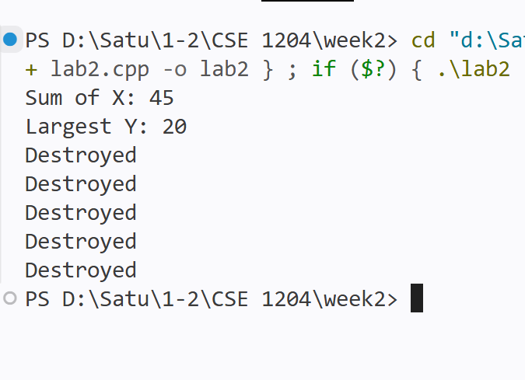

Now write and necessary codes in class and main() do the following
  - Initialize private data members x and y to 0 when empty constructor is called
  - Initialize private data members x and y using parameterized constructor is called
  - Initialize private data members x and y from another object using copy constructor
  - The data member z keeps track of total objects created
  - Write a method to initialize x and y
  - Write a method to display data member z only
  - Write a method to display x,y and z where their values can’t be changed
  - Create five objects
  - Find the sum of x
  - Find the object number whose y value is maximum
  - Write destructor
- Problem Statement : Write a class A with two data member a and b. Now set the values of a and b of an object obj1 by a setter method SetData() and copy the values of a and b of obj1 to another object obj2 by using copy constructor.

#include<iostream>
using namespace std;
class A
{
int a;
int b;
public:
A()
{

}
void setdata(int x, int y)
{
a=x;
b=y;
}
A(const A &obj)
{
a=obj.a;
b=obj.b;
}
void display()
{
cout << a << " " << b << endl;
}
};
int main()
{
A obj1;
obj1.setdata(13,34);
A obj2(obj1);
cout << "Object 1: " ; obj1.display();
cout << "Object 2: " ; obj2.display();

return 0;
}

Output:
